EXPERIMENT-7

# 1.Implementprinciplecomponentanalysisalgo&useittoreducethedimension exp_dataset. consider the followinginstruction

1. plot magnitude of the iginevalue of sortedorder
2. plotthere-constructeddatapointsalongwidtheclasslvlusing1&2PCSfor reconstruction.
3. classify the dimension reduced dataset gaussianclassifier.

Solution:-

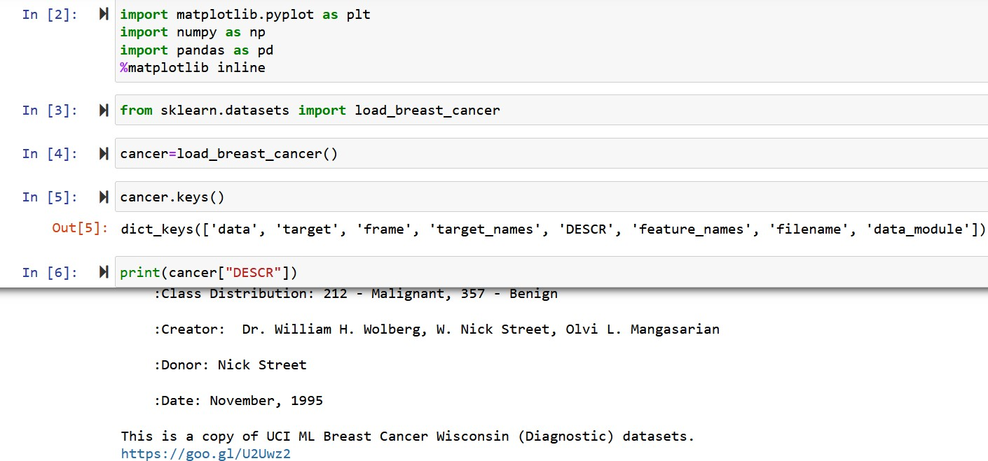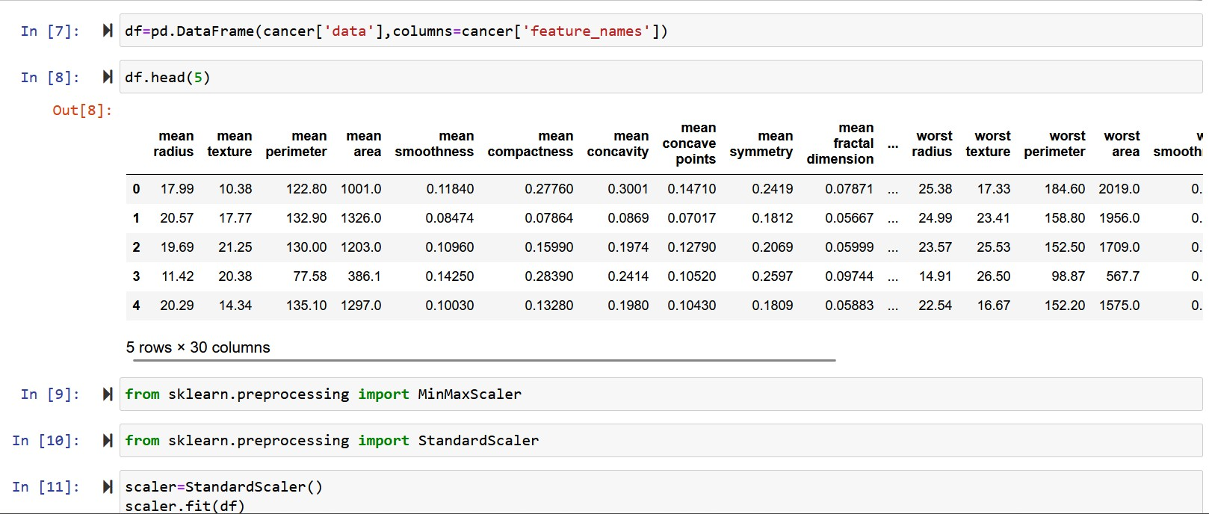

|  |  |  |  |  |  |  |
| --- | --- | --- | --- | --- | --- | --- |
|  | Out[11]: | StandardScaler() | |  | | |
| In | [12]: #{ | scaled_data=scaLer.transform(df) | |
| In | [l5]: #{ | scaled_data | |
|  | Out[13]: | array([[ 1.09706598, -2.07333501, | | 1.26993369, | ..., 2. 296B7613, | |
| 2.75062224,  [ i.B2sB2e61, | | | 1.93701461],  -e .ss363241, | 1. 68595471, | . . , | 1. eB7e 4s , |
| *-B.*243B8967, | | | 6.2B118999] , |  |  |  |
| [ i . 5y9B8B1 , | | | e .4s618695, | 1. 56650313, | . . . , | 1. 95500035, |
| 1.152255 , | | | 6.26139121] , |  |  |  |

[0.70228425, 2.0455738, e.67267578,..

-1.10454895, -8.31840916],

## , 0.4t<esB6s,

[1.83834103, 2.33645719, 1.98252415,..., **2.28998549,**

## i.szsesse1, 2.2196352B],

[-1.B0846125, 1.22179204, -1. 81438B51, . . . ,-1.74566282,

-0. €I4813B2 , -e .7s120669] ] )

In[14]: #{fromsklearn.decompositionimportPCA In[l5]: #{pca=PCA(n_components=2)

In[16]: #{pca.fit(scaled_data) Out[16]:PCA(n_components=2)

In [L7]: **§|x_pca=pca.** transf-orm( sca1ed_data )

In [18]: §| sca1ed_data. shape Out [18] :(569,30)

In [L9]: §| x_pca. shape Out [19] :(569,2)

|  |  |  |  |  |  |
| --- | --- | --- | --- | --- | --- |
| In | [20]: §| | sca1ed_data | | | |
| Out[20]: | | array([[1.69706398, | -2.07333501, 1.26993369, | ... , | 2.29607613, |
|  | | 2.75062224, | 1. 93701461] , |  |  |
|  | | [1.B2982061,  -B.24388967, | -B.35363241, 1.6B595471,  0.28118999], | . . . , | 1.0870843 , |
|  | | [ 1.57988811, | 0.45618695, 1.56650313, | .., | 1.95500035, |
|  | | 1.152255 | 0.20139121], |  |  |
|  | | [670228425,  -1.10454B95, [1.83834103, | 2.0455738,0.67267578,  -B .**31g489l6]** ,  2.33645719, 1.98252415, | ...,  . . . , | 0.41406869,  2.2899B549, |
|  | | 1.9190g301, | 2.21963528] , |  |  |
|  | | [-1.80g40125, | 1.22179204, -1.g1438851, | ..., | -1.74506282, |

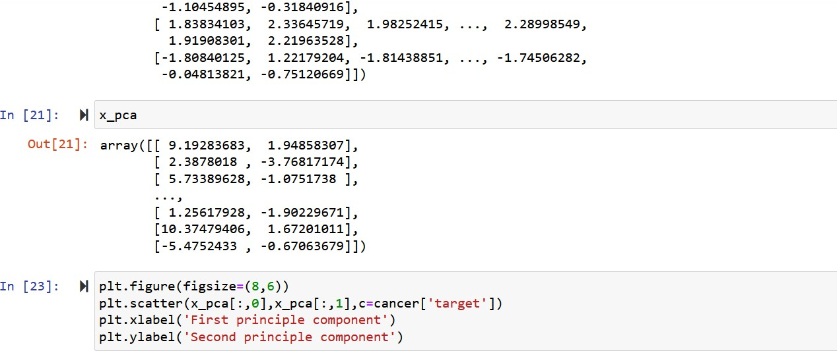

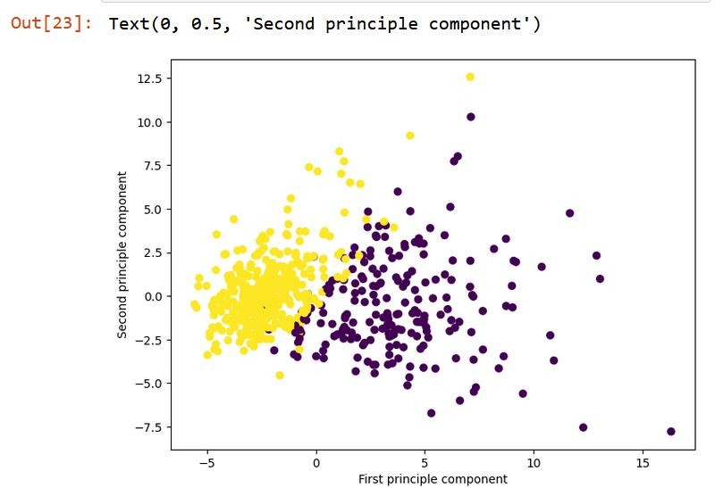

**NAME- Abdul Zahid Khan Quadri**

**ROLL No- CSE20065**

**REGD No- 20010059**

**GROUP- 1 ‘A’**